The William Paterson Memorial Targa Rally 2017

On Sunday 14th May 2017 South of Scotland Car Club ran their 4th Annual Targa Rally, sponsored for the 2nd year by the three Paterson Brothers, which was another great success.
Starting of from one of the co-sponsors premises Oaktree Garage on Annan Road Dumfries, heading off to the first lot of morning tests at Oakbank Services, Collin Quarry, and Jones’s Yard, which were all run twice, before lunch halt at Auldgirth Inn.
Afternoon tests were also run twice at Dalswinton Estate, Sandbed, and Windyhill &Windmills all tests put up some great challenges for all competitors from fast flowing to tight and twisty tests.
Coming out on top were Steve Retchless from Northallerton & Sasha Heriot from Chesterfield in their road rally spec Mk2 Escort 1st Overall winning by a margin of 11 seconds from Stuart Paterson & Alice Paterson in 2nd place in a very standard looking Renault Clio 1.5 Dci ,a further 15 second back were another Renault Clio but a 1.2 version with David Crosbie and Greg Mc Knight
I would also like to thank the main sponsors Oaktree Garage, Threave Rural & Craigiebank Garage for their support ,also all the landowners Oakbank Services, Jones’s Sawmills, & Dalswinton Estate, and all marshals and officials of whom this event would not be possible.

Thank You Ian Crosbie

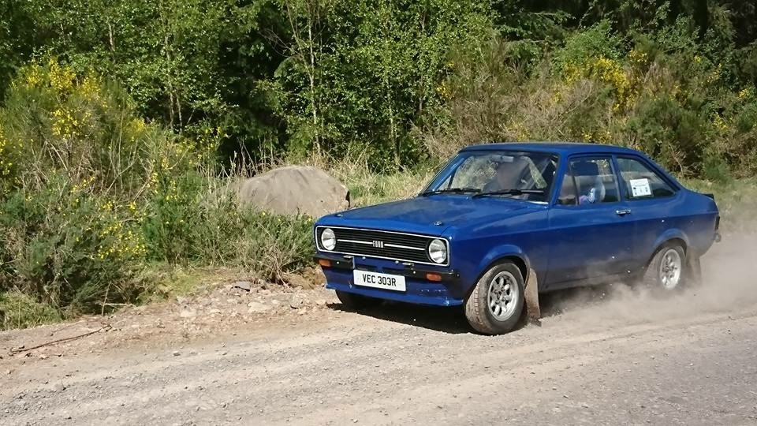
1STOverall Steve Retchless & Sasha Heriot

The William Paterson Memorial Targa Rally 2017
AWARD WINNERS
 | No | Driver | Co-Driver | Car | Pos'n
1st Overall | 6 | Steve Retchless | Sasha Heriot | Ford Escort Mk2 | 1st O/A
1st Class MA | 5 | Jack Palmer | Tom Hampton | Rover 25 | 1st in class
1st Class MB | 7 | Simon Jennings | Clive White | Peugeot 106 Gti | 1 st in class
2nd Class MB | 2 | John Bertram | Andrew Fish | Escort Mexico Mk1 | 2nd in class
3rd Class MB | 3 | Craig Wallace | Charley Sayer-Payne | Toyota Corolla | 3rd in class
1st Class EB | 10 | Drew McLean | Karina Mc Lean | Mazda Mx5 | 1st in class
2nd Class EB | 12 | Geoff Bateman | Maggy Bateman | Peugeot 205 Gti | 2nd in class
3rd Class EB | 16 | Quentin James | Tom Howe | Citroen C2 Gt | 3rd in class
1st Class NA | 19 | Stuart Paterson | Alice Paterson | Renault Clio Dci | 1st in class
2nd Class NA | 20 | David Crosbie | Greg Mc Knight | Renault Clio 1.2 | 2nd in class
1st Class NB | 17 | Gavin Murray | Richard Murray | MGZR | 1st in class
2nd Class NB | 21 | Alan Paterson | Colin Maxwell | Mazda Mx5 | 2nd in class
3st Class NB | 15 | Chris Marsh | Andy Beaumont | Proton Satria Gti | 3rd in class

