***South of Scotland Car Club Ltd***

***"Maximum Attack" Autotest***

**Saturday 22nd July 2017**

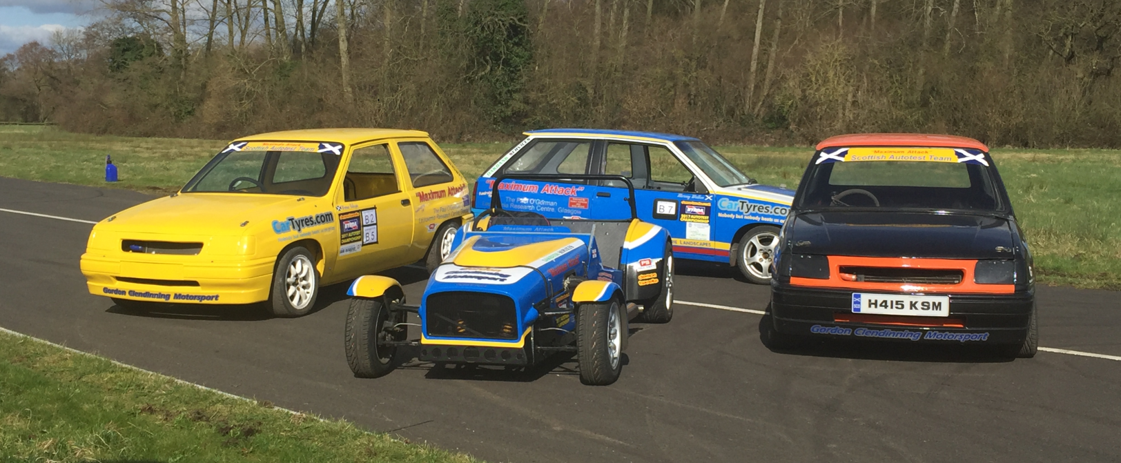

***With the kind permission and Support of NWF Agriculture Ltd***



***Supplying high quality dairy, beef and sheep feeds***

***across South West Scotland and Cumbria***



**Supplementary Regulations**

1 The South of Scotland Car Club Ltd. will organise a National B status autotest on Saturday 22nd July 2017.

The event will be held at **NWF Agriculture Ltd. Hanger 8, Heathhall Industrial Estate, Dumfries, DG1 3PH.**

2 The meeting will be governed by the General Regulations of the Motor Sports Association Ltd

(Incorporating the provisions of the International Sporting Code of the FIA),

these supplementary regulations and any written instructions that the organising club may issue for the event.

3 MSA permit number: Applied for

4 The event is open to:

a) registered entrants in the **2017 Link-up Ltd. MSA Autotest Championship**,

the **demon tweeks *Direct* BTRDA Autotest Championship**,

the **BTRDA Allrounders Championship** supported by **NuCasa**

the **Sam Bowden Garage Services ANICC Autotest Championship**,

the Motorsport Ireland Autotest Championship

b) members of clubs affiliated to the ANWCC, AWMMC, ANECCC and ANCC.

5 The event is a qualifying round of the:

**2017 Link-up Ltd. MSA Autotest Championship**

**2017 demon tweeks *Direct* BTRDA Autotest Championship**

**2017 BTRDA Allrounders Championship supported by NuCasa**

6 All competitors must produce a valid MSA competition licence or MI equivalent,

a club membership card and a championship registration card if applicable.

7 The programme for the event will be:

9.00am - Noise test, Scrutineering and Signing on.

**Any competitor not signed on by 10.15am may be excluded.**

10.30am - A drivers briefing.

10.45am - The first test will start. **SHARP**

Lunch Break There will be a 45 minute lunch break for marshals, officials and competitors,

when 3 rounds of tests have been completed.

**NOTE. If we are running behind the time schedule, then the lunch break may be reduced to 30 minutes**

3.30pm – Approx - The event will conclude

4.00 pm – Approx. **, Prize Giving will be at event location once provisional results finalised**.

8 The event will consist of five classes as follows:

Class A Saloon cars under 11' overall length Including Mini saloons with non mini engines

Class B Saloon cars over 11' overall length

Class C Sports cars and Sports kit cars

Class D Specials

Class E Road going series production cars

**Note** Class E, All vehicles in this class must be capable of being driven on the road.

They must be taxed and have a current M.O.T. Certificate (if applicable) which will be checked at signing on.

9 The awards for the event will be presented on site at competition venue as follows:

FTD - The ***"Maximum Attack" South of Scotland Car Club*** Autotest Trophy + an award

1st in each class an award

2nd in each class an award

3rd in each class an award (subject to a minimum of 5 class entries)

1st Novice an award (defined as a competitor who has not won a class award on a National B autotest)

1st Lady an award

The FTD award must be returned after 11 months or at the organiser’s request. No competitor may win more than one award. Additional awards may be presented at the clubs discretion.

10 The entry list opens on the publication of these regulations and **closes on Wed 19th of July**.

Entries must be made on the official entry form and accompanied by the entry fee of £35

Payable to South of Scotland Car Club Ltd

The Entries Secretary to whom all entries must be sent is: Gill Gillespie

2 Thistle Place

Heathhall

Dumfries

DG1 3UT

gillgillespie@btinternet.com tel. 07850 027132 (1800-2100 only)

11 The maximum entry for the event is 45. The minimum entry is 20. The minimum for each class is 3, should any of the

minimum figures not be reached the organisers have the right to either cancel the event or amalgamate classes as necessary.

12 **Officials:**

Clerk of the Course Mike Sones

Club Steward TBC

Entry Secretary Gill Gillespie

Noise test and Scrutineer Peter Clingan

Results TBC

Child Protection Officer Kelsey Gillespie

13 Provisional results will be on display during the event and as soon as possible following the conclusion of the

event. Any protests must be made in accordance with Section C, otherwise the results will be made final and the

awards will be presented at the event location once result finalised.

14 Practising will **NOT** be allowed and competitors will **NOT** be allowed to walk on the tests once the event has

started.

15 Test diagrams will be added to the final instructions and will be available on the SOSCC website from

Wednesday 19th July. **Competitors will have a maximum of 6 runs at each test.** Cars will be identified by

numbers supplied by the organisers. Timing will be by electronic timing beam and digital displays. LCD

Stopwatches will be used in the event of equipment failure. Competitors will start in their own time upon clearance

from the timing marshal, **however to keep the event flowing we would ask all competitors to be ready to**

**start the test within 30 seconds of arriving at the start line.**

Competitors MUST run in order, unless permission is granted by the Clerk of the Course. Failure to comply may

result in a 30 second penalty. In the interests of safety, any competitor failing to stop astride the finish line, and / or before the baulk line following the finish line, **will** be penalised 5 seconds for **each offence**.

**If you suffer a mechanical breakdown then please inform the Clerk of the Course who will arrange for you**

**to slot back into the running order where possible.**

16 The General Regulations of the MSA apply as written, except the following which are modified

A vehicle may be entered by two different competitors

M.4.2 Pylons may be less than 1 metre high

Table M.7.c. 20 seconds

Table M.7.c 5 seconds

In any test diagram illustrating a test, dimensions will be approximate and only for guidance. Indications of the

direction of travel of the competing car when crossing a line, passing between markers will be mandatory but not

exclusive (ignoring shunts to avoid markers) A maximum penalty will be applied when the mandatory sequence of

manoeuvres has not been correctly completed. A test will not be deemed incorrect if the driver realises their

mistake, returns to the point at which the mistake occurred and then completes the test correctly as required by

the test diagram.

17 For those with Sat Nav. **the postcode is DG1 3PH**. The test site will also be arrowed from Dumfries bypass.

18 **Please respect the landowners and put any rubbish in the bins provided or take your litter away with you.**

**Also, please report any oil or contaminate spillages to the Event Site Marshals or any official.**

19 South of Scotland Car Club Ltd Child Protection Policy

A child's welfare is paramount. All children whatever their age, culture, disability, gender, language, religious

belief and or sexual identity, have the right to protect themselves from abuse. All suspicions and allegations of

inappropriate behaviour will be taken seriously and responded to swiftly and appropriately. As defined in the

Children's Act 1989, anyone under the age of 18 years old should be considered as a child for the purposes of

this document.

If you have any concerns about child protection while attending this event, then please urgently contact the South

of Scotland Car Club's Child Protection Officer Kelsey Gillespie 07732 666 215

***"we look forward to welcoming you to Dumfries"***

*First of all,* ***South of Scotland Car Club*** *would like to thank all the BTRDA competitors who voted our event*

***"the best round in the 2016 BTRDA National Championship"*** *An honour and a fantastic achievement for*

*the club second year in a row.*

*Our aim is to give you (the competitor) a memorable, sociable, worthwhile and cost effective weekend of*

*autotesting in south west Scotland. The format for our 2017 autotest weekend will be very similar to last year.*

*Thanks to* ***NWF Agriculture Ltd*** *we have retained the same venue as last year. We have taken*

*onboard all the comments since last year's event and hope to provide another great weekend with a few*

*improvements and subtle changes here and there to make the events better and also run smoother.*

*The venue for our event is located just 30 minutes from the M6 at Gretna, just north of Carlisle and 90 minutes from the Port of Cairnryan and the Northern Ireland ferries.*

*The* ***"Maximum Attack" Autotest*** *on Saturday will be the main event of the weekend, counting towards the*

***BTRDA*** *and* ***MSA National Autotest Championships*** *and the* ***BTRDA Allrounders Championship****.*

*On Sunday,* ***The "Maximum Attack" Challenge*** *will be a more relaxed non championship individual event for the regular championship competitors and the up and coming local clubmen.*

*There will be on-site catering Saturday and Sunday please support*

*Information about the* ***"Maximum Attack" fundraising appeal*** *this is South of Scotland Car Club Ltd nominated charity for this weekend*

*Also, not forgetting, the all-important toilet facilities.*

***Thanks to NWF Agriculture Ltd for their continued support and use of the venue***

**South of Scotland Car Club's nominated charity for this special weekend**



South of Scotland Car Club Ltd

"Maximum Attack"

Autotest 22nd July 2017

Please complete in BLOCK CAPITALS

|  |
| --- |
| Driver : |
| Address |
| Post Code |
| E-Mail |
| Contact No’s: / |
| Next Of Kin: / Contact No |
| Club : /Competition Licence No |
| Double Entry : Y / N /Additional Driver : |

|  |  |
| --- | --- |
| Car Details |  |
| Car Manufacturer | Model |
| CC | Class |

|  |  |
| --- | --- |
| Entry Fee |  |
| Full entry fee £35 | £ : |
|  |  |
| Total Payable to ”South of Scotland Car Club Ltd” | £ : |

Please return this fully completed form with a cheque made payable to ( South of Scotland Car Club Ltd)

Gill Gillespie

2 Thistle Place,

Heathhall,

Dumfries,

DG1 3UT tel. 07850 027132 (1800-2100 only) or email: gillgillespie@btinternet.com

"I declare that I have been given the opportunity to read the General Regulations of the MSA and, the Supplementary Regulations for this event and agree to be bound by them. I declare that I am physically and mentally fit to take part in the event and I am competent to do so. I acknowledge that I understand

the nature and type of competition and the potential risk inherent with motor sport and agree to accept that risk".

State your age if you are under 18 years of age _______

Signed..................................................................................................... Entrant/Driver Date ..........................................

*If the driver is under 18years of age, the entry MUST be authenticated by the parent, legal guardian or guarantor by sighing the statement below " I understand that I shall have the right to be present at any procedure being carried out under the Supplementary Regulations issued for the event and the General Regulations of the MSA". As the Parent/Guardian/Guarantor, "I confirm that I have acquainted myself and the minor with the MSA General Regulations, agree to pay any appropriate

charges and fees pursuant to those Regulations (to include any appendices thereto) and hereby agree to be bound by those Regulations and submit myself without reserve to the consequences resulting from those Regulations (any subsequent alteration thereof). Further, I agree to pay the liquidated damages any fines imposed upon me to the maxima set out in Part 3, Appendix 1".

Signed .......................................................................................................... Parent/Guardian/Guarantor Date………………………………..

|  |  |  |  |  |
| --- | --- | --- | --- | --- |
| Received Date | Paid | Accepted E-mail | Finals E-mail |  |
|  |  |  |  |  |